

In this lab you will explore Watson Studio

Objective for Exercise:

* How to create a Watson Studio service instance
* How to create a project in Watson Studio
* How to create project on Watson Studio
* How to load a notebook in Watson Studio.

*If you have not created a Watson service before proceed with Step 1, otherwise go to Step 2*

**Exercise** - Create a project on Watson Studio

**Step 1:** For New Users (with no Watson service):

For this project, you will use your IBM Watson Studio account from the previous chapter.

Go to the IBM Cloud Watson Studio page:

[Click here](https://cloud.ibm.com/catalog/services/watson-studio?cm_mmc=Email_Newsletter-_-Developer_Ed%2BTech-_-WW_WW-_-SkillsNetwork-Courses-IBMDeveloperSkillsNetwork-PY0101EN-SkillsNetwork-19487395&cm_mmca1=000026UJ&cm_mmca2=10006555&cm_mmca3=M12345678&cvosrc=email.Newsletter.M12345678&cvo_campaign=000026UJ)

You will see the screen in the figure below. Click the icon in the top left corner:

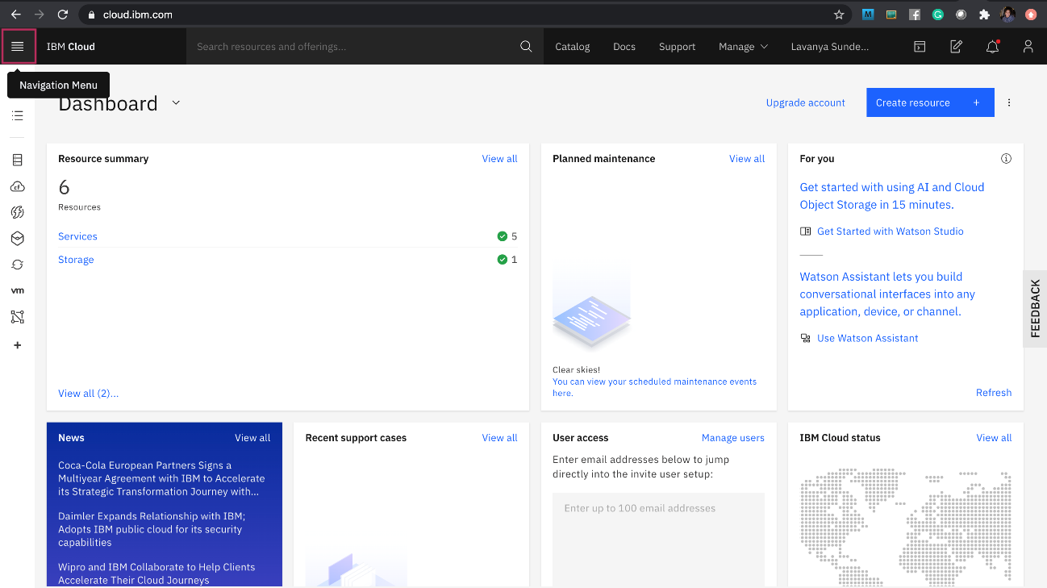

Then click **Watson**, as shown below:

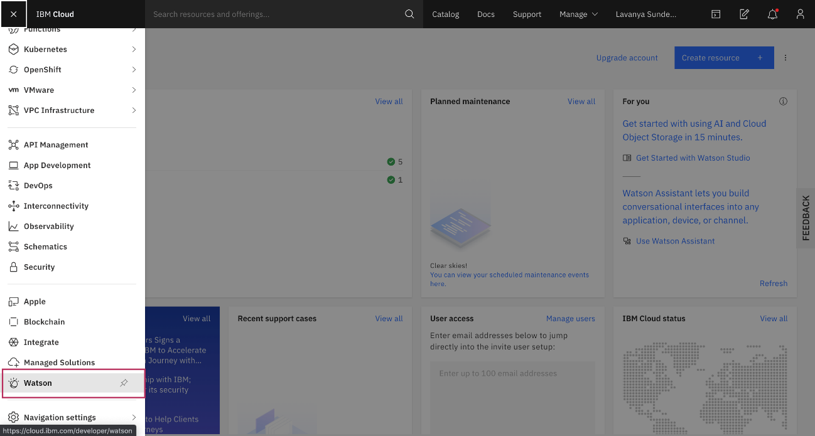

You are in the Watson landing page. Click on the **Watson Services** menu.

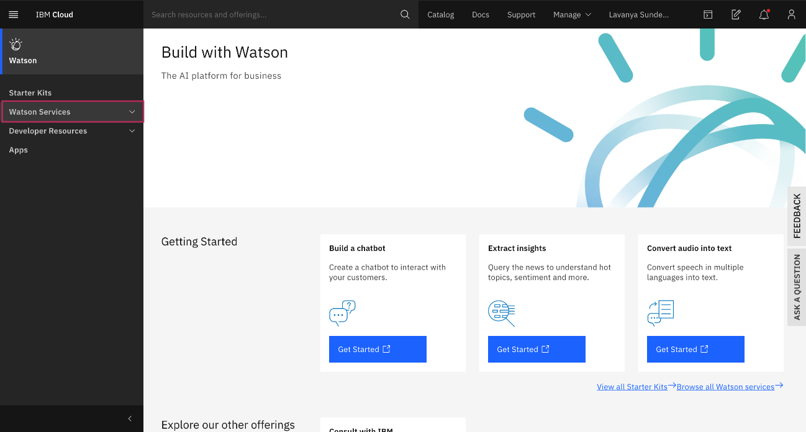

Then click **Browse Services** and on the page scroll down and choose **Watson Studio**

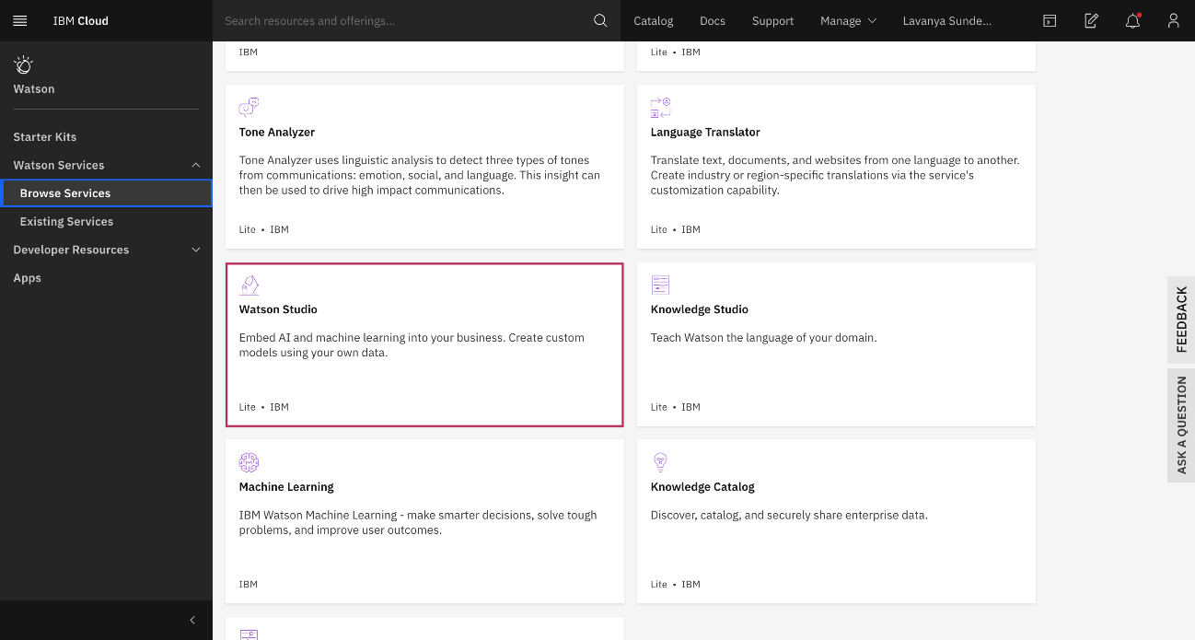

Scroll down and select **Watson Studio - Lite.** To create a Watson service using the Lite plan, click **Create**.

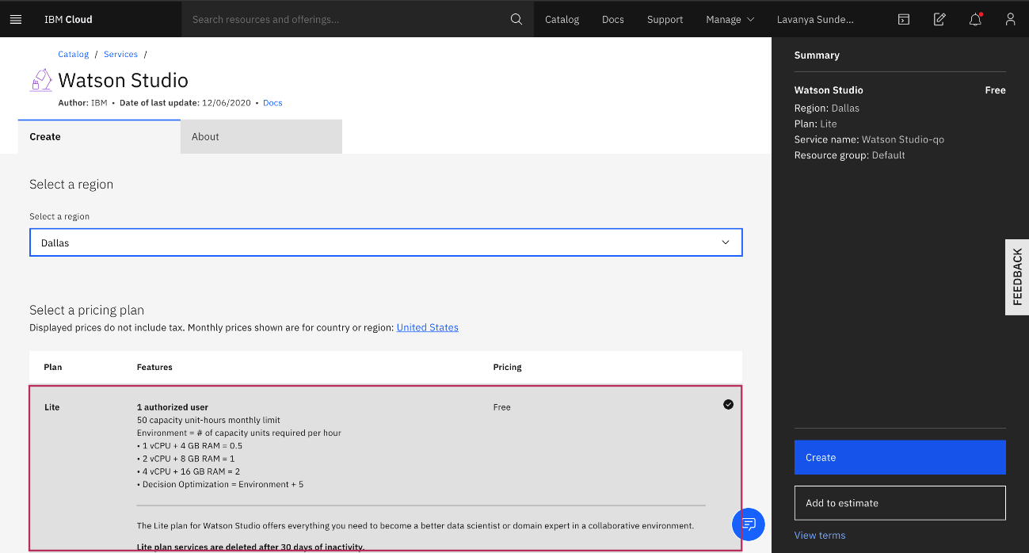

Now click **Get Started.**

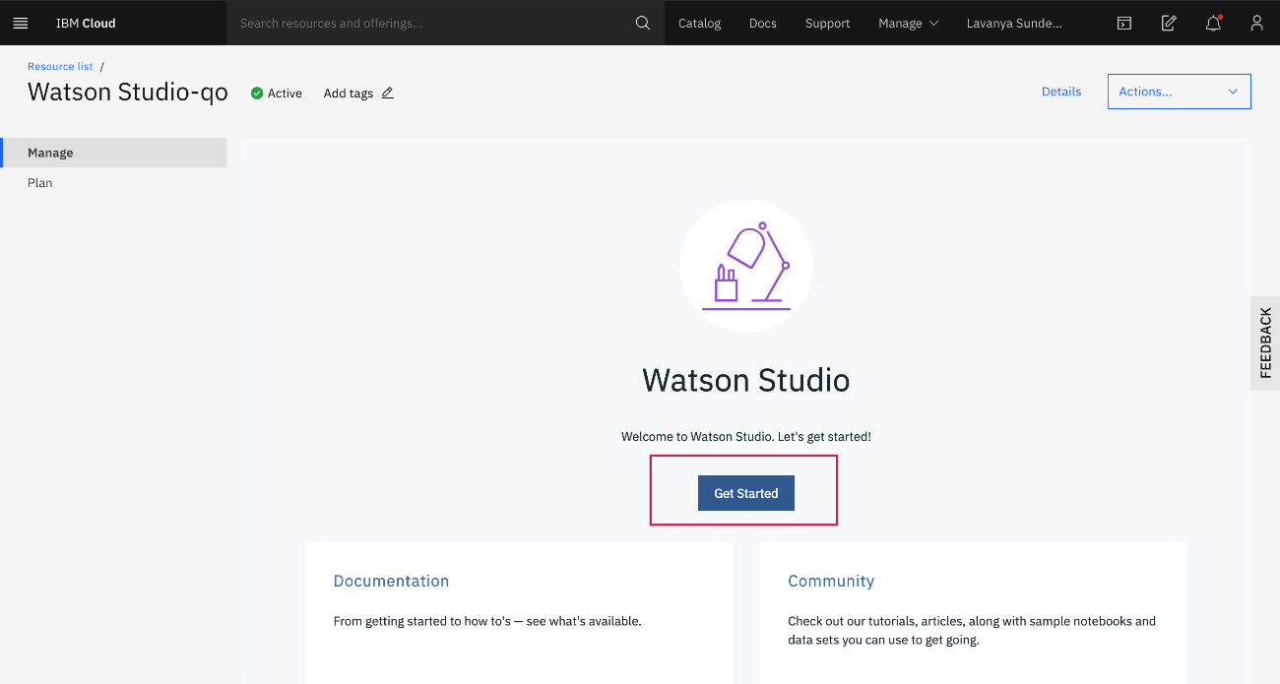

**Step 2:** For Existing Users (who already have Watson Service): Go to the IBM Cloud Dashboard and click Services.

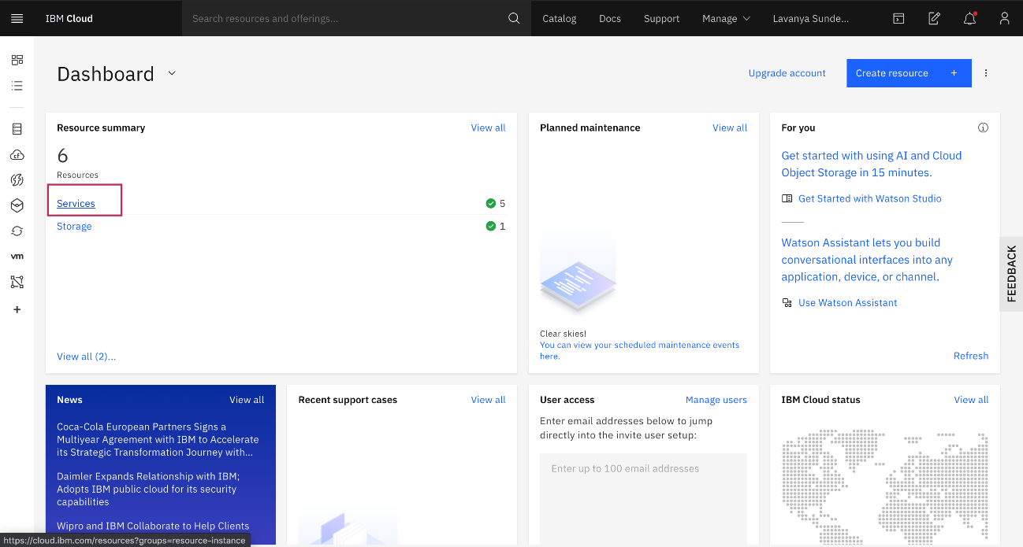

When you click on Services, all your existing services will be shown in the list. Click the Watson Studio service you created:

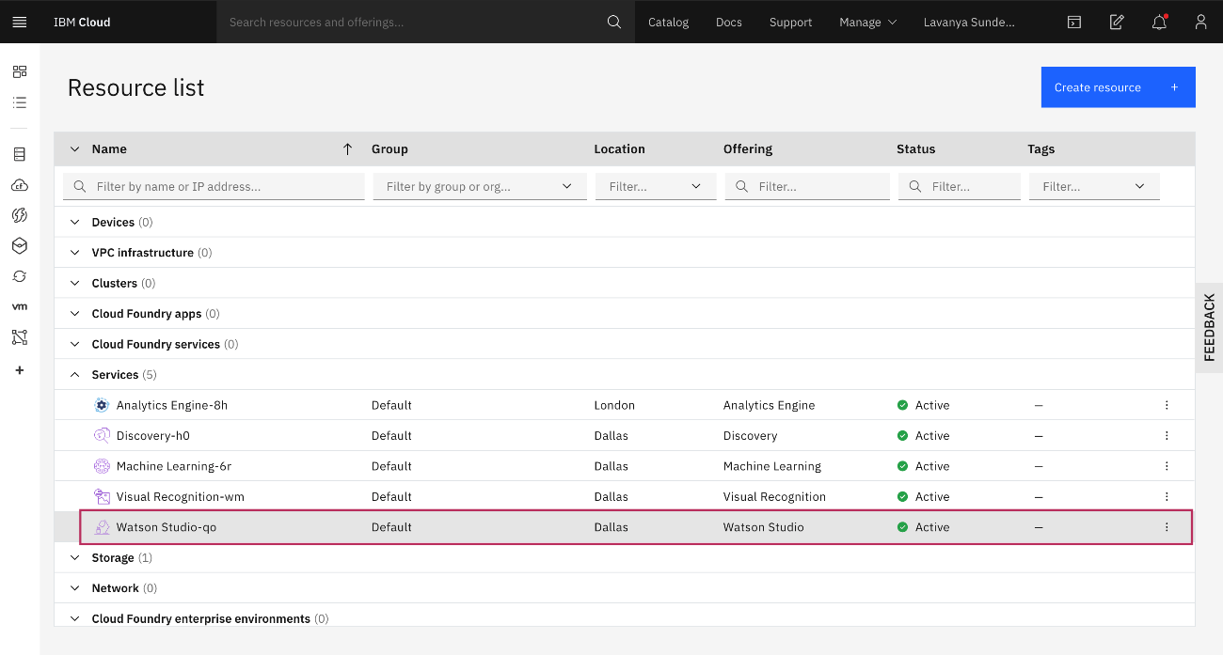

**Step 3:** Creating a Project Now you have to Create a project.

Click on **Create a project**

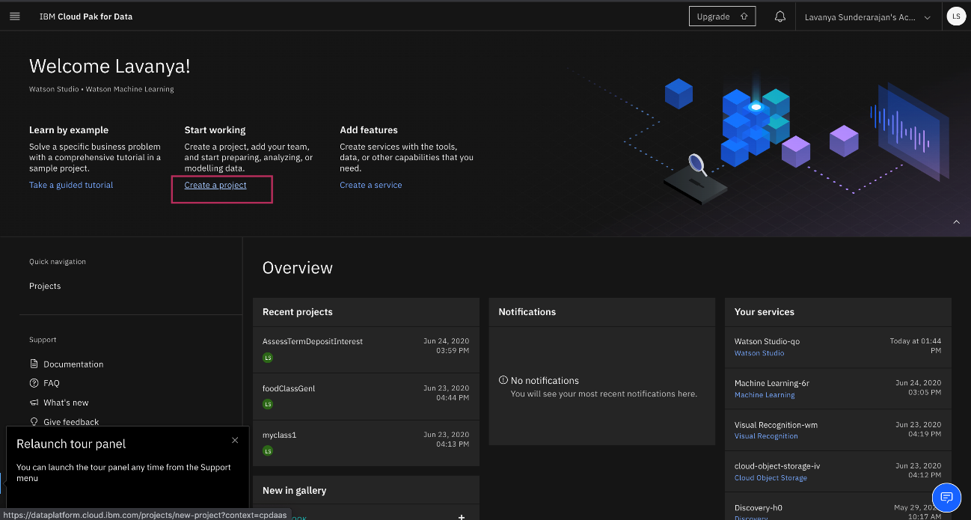

On the Create a project page, click **Create an empty project**

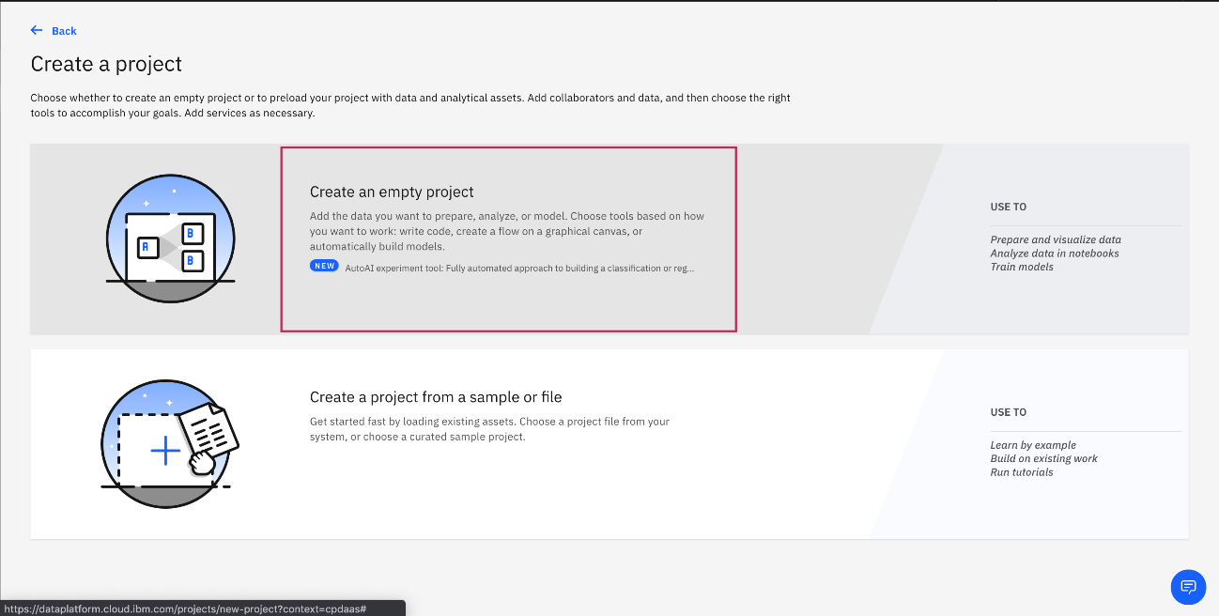

Provide a **Project Name** and **Description**, as shown below:

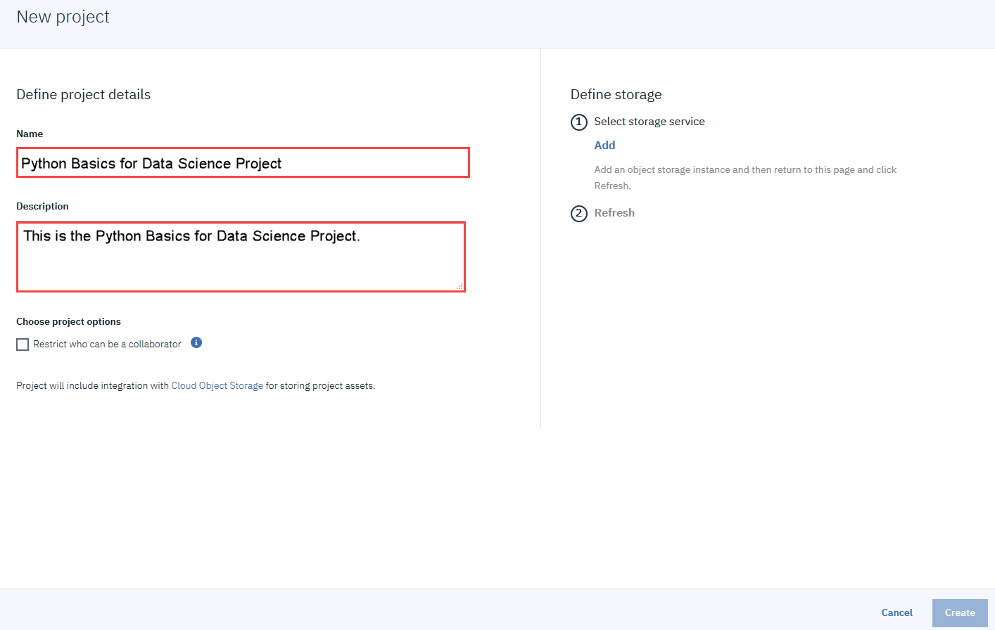

You must also create storage for the project. Click **Add**

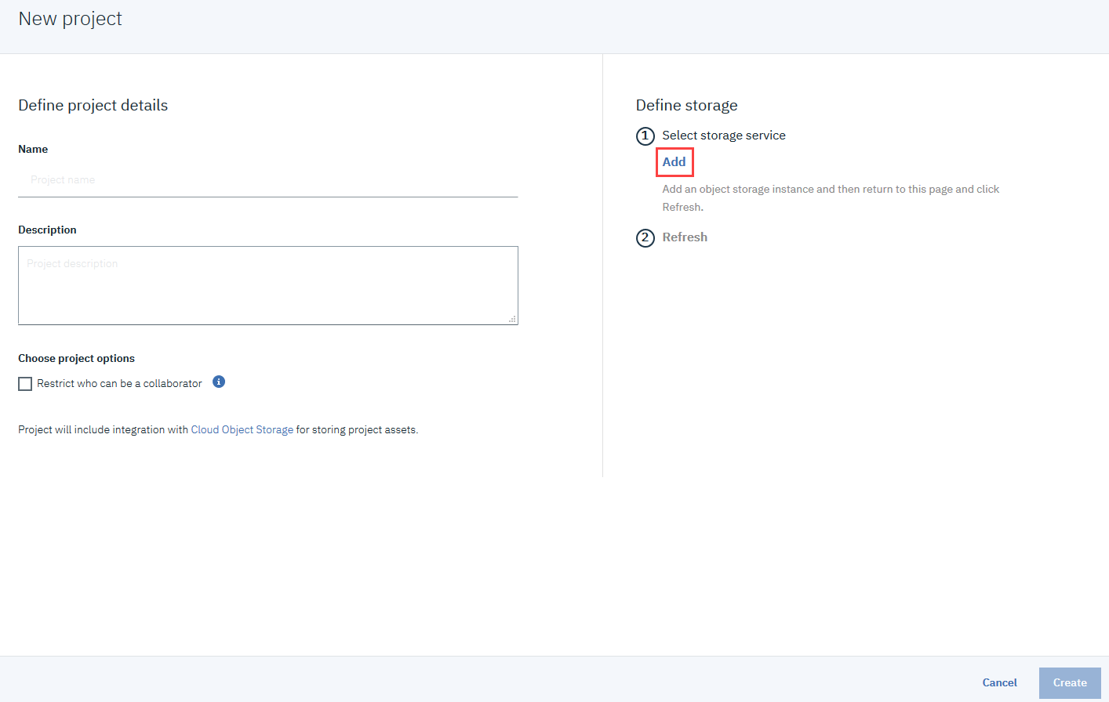

On the Cloud Object Storage page, scroll down and then click **Create**.

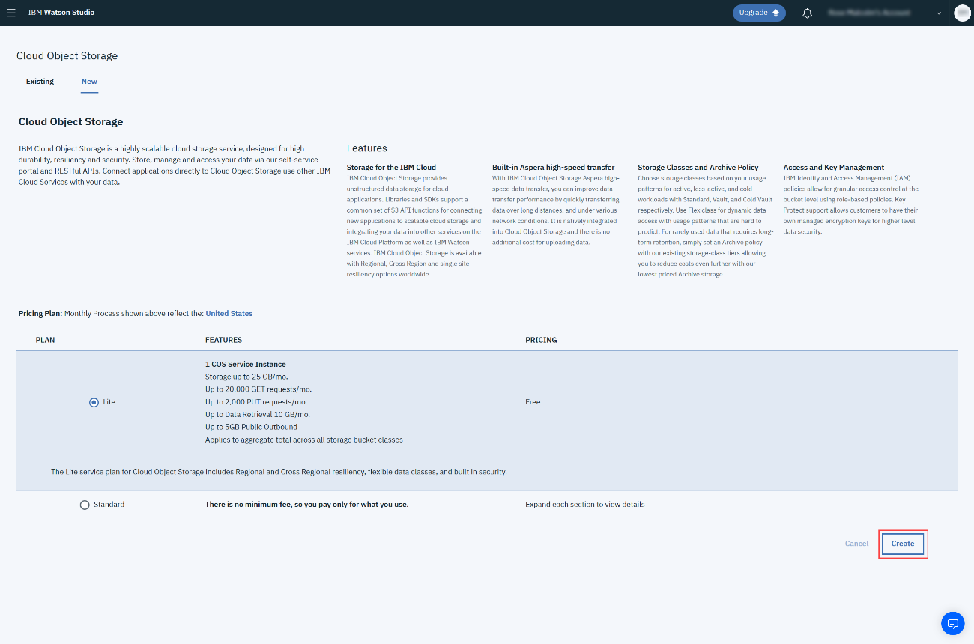

In the Confirm Creation box, click **Confirm.**

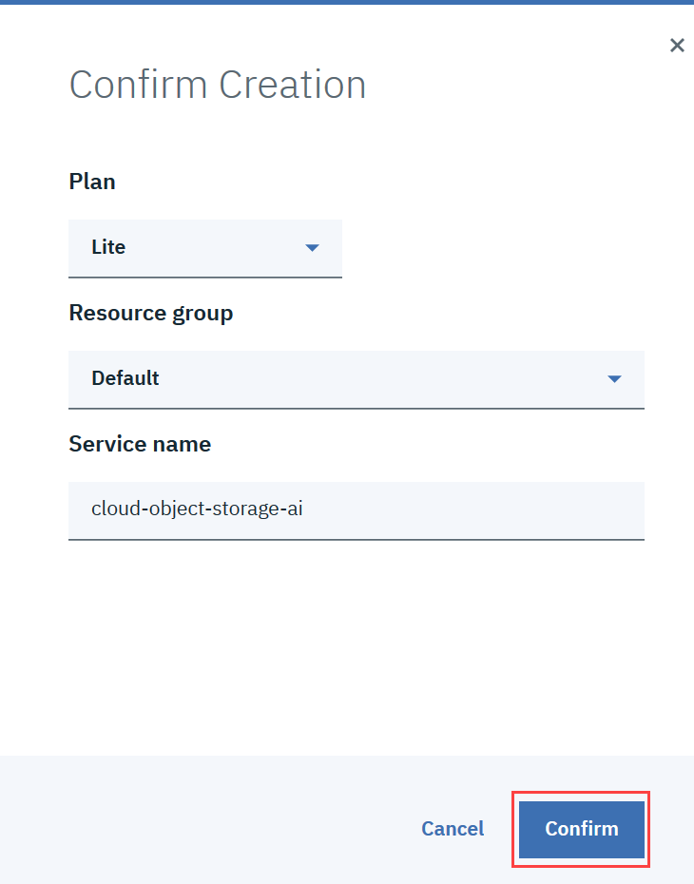

On the New project page, note that the storage has been added, and then click Create.

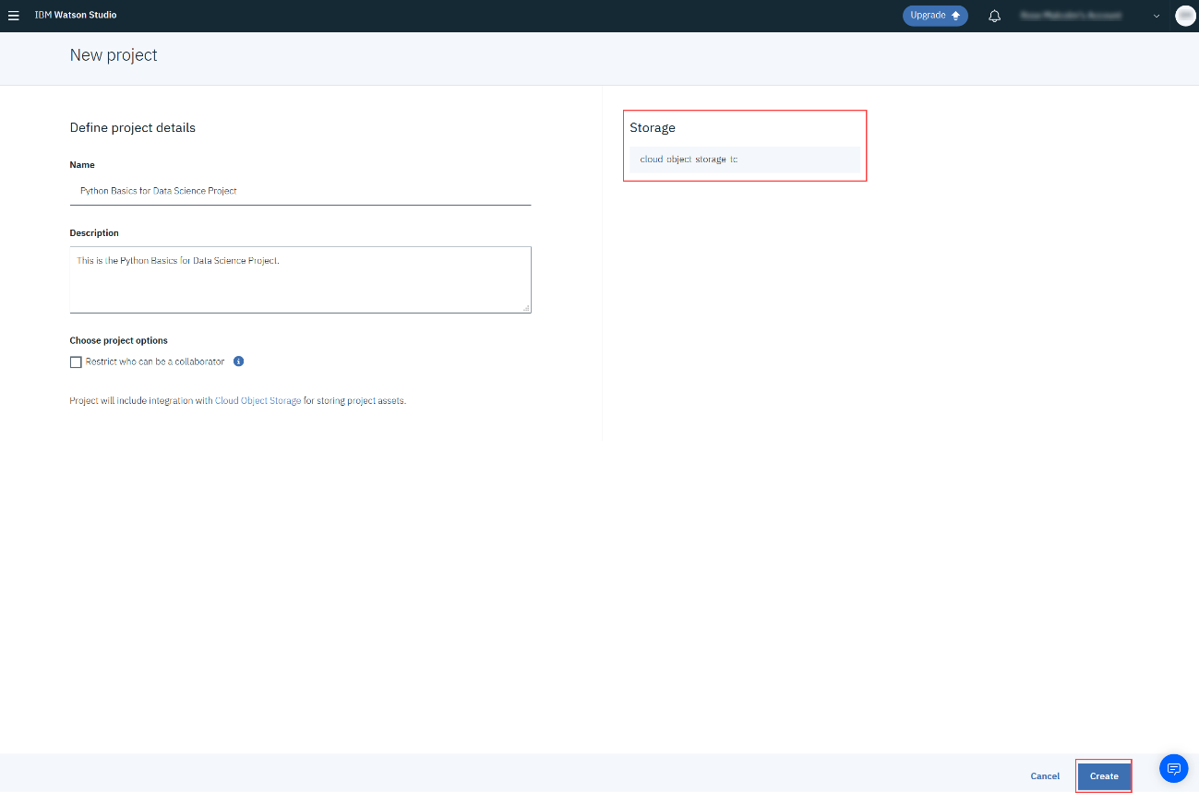

**Step 4:** Adding a Notebook to the Project: You need to add a Notebook to your project. Click Add to project.

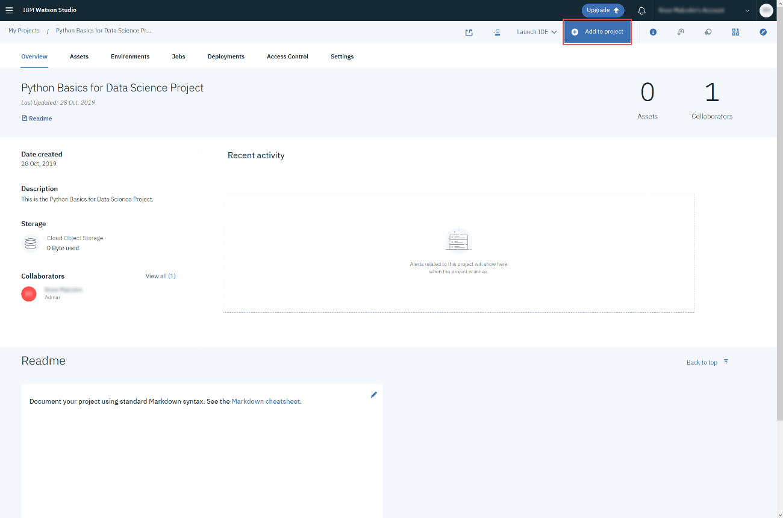

In the list of asset types, click Notebook:

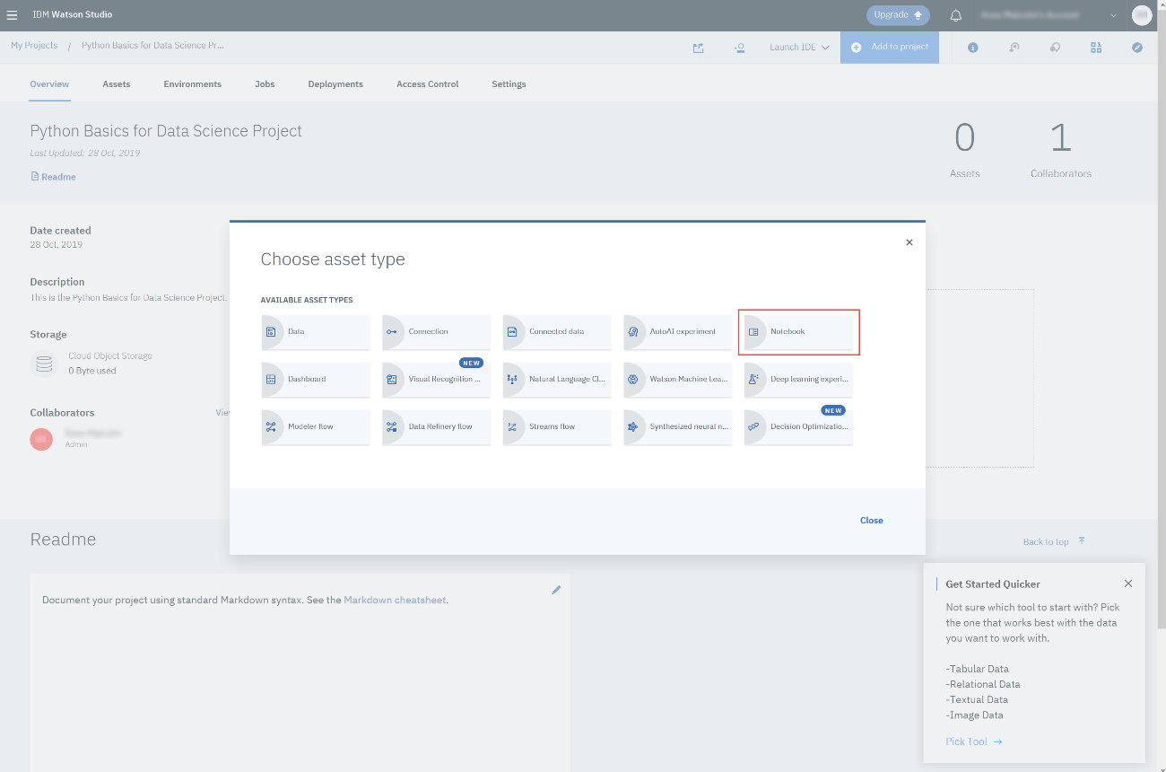

On the New Notebook page, enter a name for the notebook, and then click **From URL**. Copy this [link](https://cf-courses-data.s3.us.cloud-object-storage.appdomain.cloud/IBMDeveloperSkillsNetwork-PY0101EN-SkillsNetwork/labs/Module%204/PY0101EN-4-3-LoadData.ipynb).

Paste it into the **Notebook URL** box, and then click **Create Notebook**.

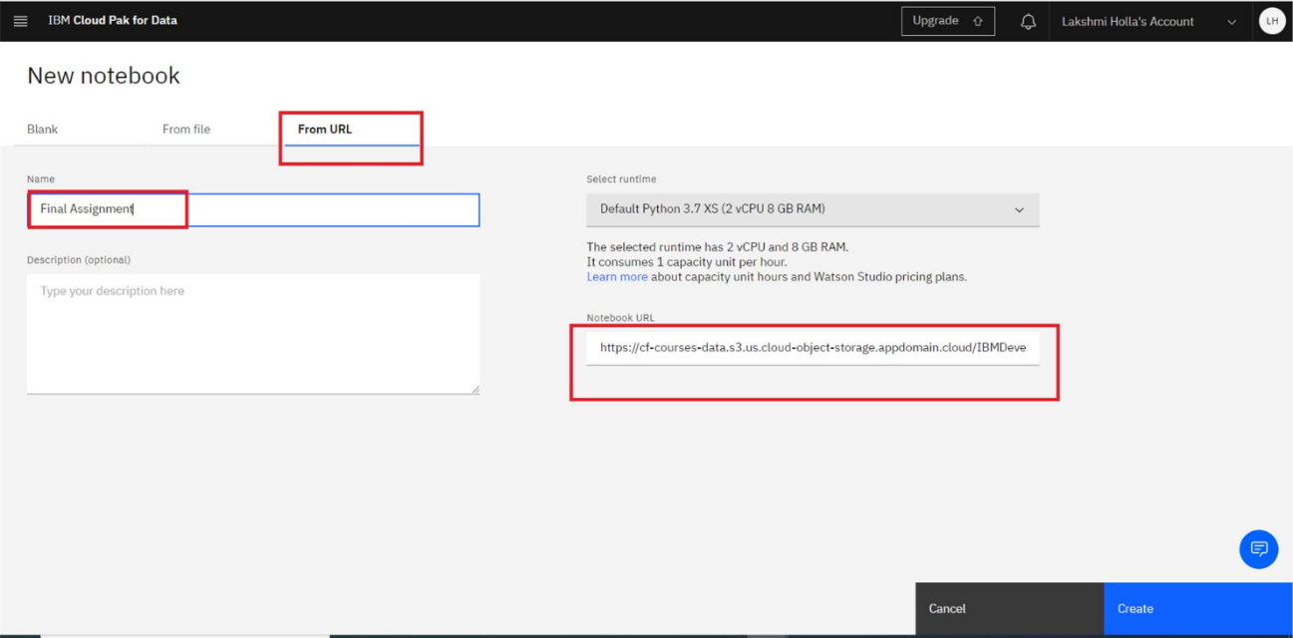

You will see this Notebook:

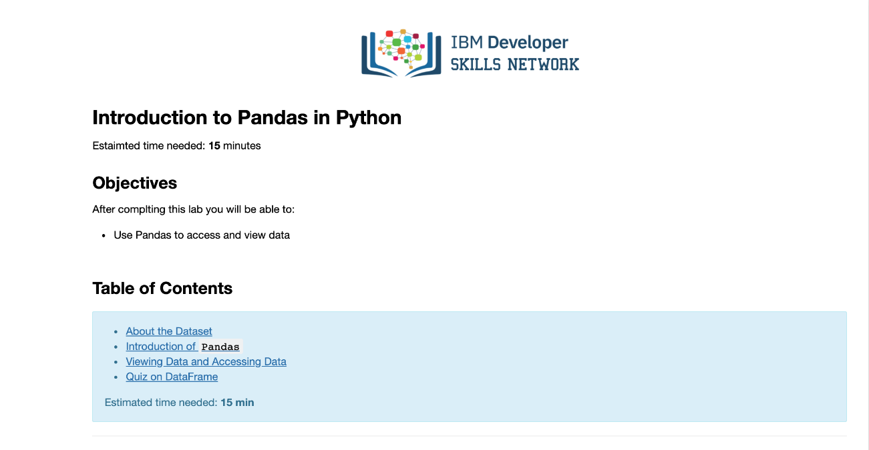

Once you complete your notebook you will have to share it. Select the icon on the top right a marked in red in the image below, a dialogue box should open, select the option all content excluding sensitive code cells. Share it in the Social Network platform, you desire.